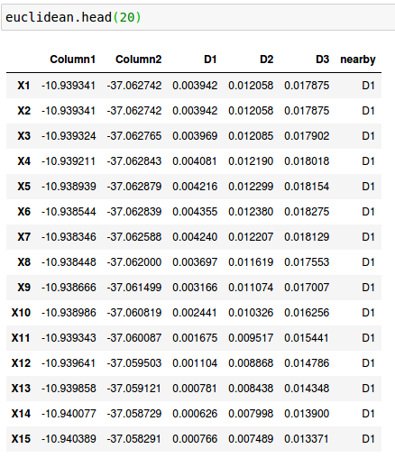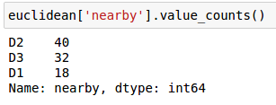**Similarity matrix for Euclidean for top 20 columns: X denotes data points and D1,D2,D3 are cluster centers**

POINTS IN EACH CLUSTER AFTER

INITIAL ITERATION

**METHOD FOR CALCULATING NEW CENTERS FOR EACH ITERATION**

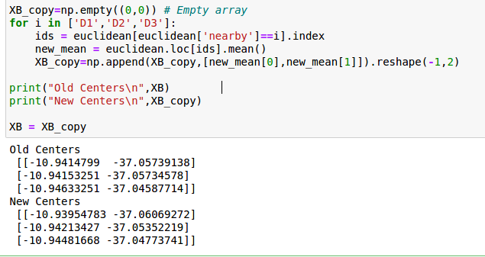

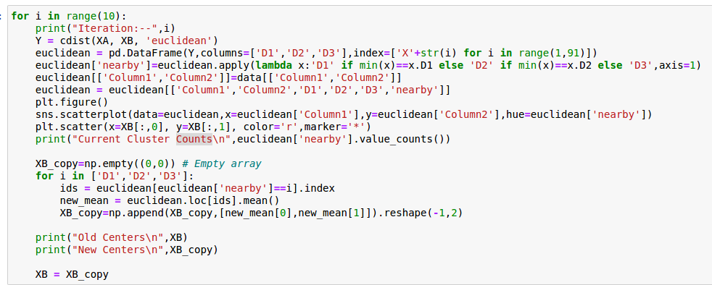

**LOGIC FOR ITERATION. Refer to ipynb for Output**

**SCATTER PLOT AFTER 10 ITERATION**

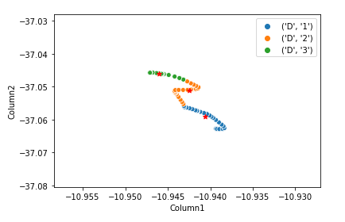**Red Color Points--> Cluster Centers**

**Similar Process for other distance measures**

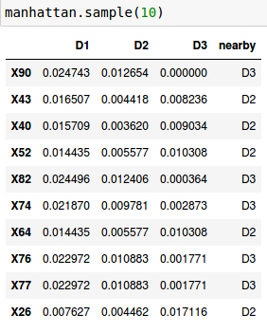

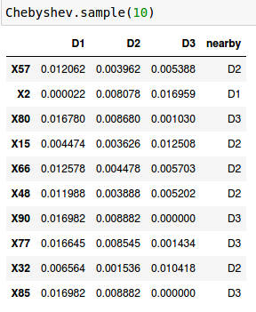**Similarity matrix for Manhattan Similarity matrix for ChebyShev**

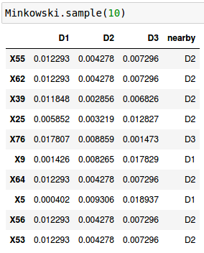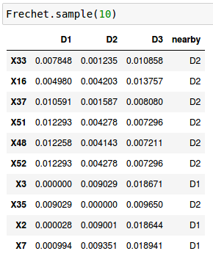**Similarity matrix for Minkowski Similarity matrix for Frechet**

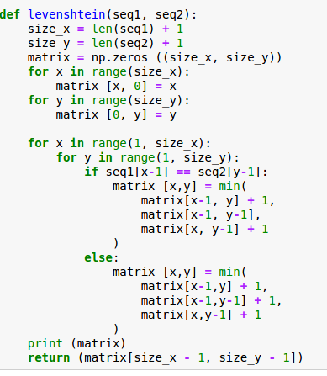

**LEVENSHTEIN MEASURE FOR STRING COMPARISION**

**A S T O U N D I N G**

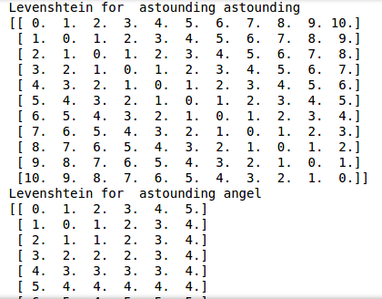

**A**

**S T O U N D I N**

**G**